COVID-19 Safety Planning AS OF 7:58a.m. 8/25/21

COVID-19 Planning Coordinator: Destiny Sparks, Executive Director; back-up is Elizabeth Kneip, Office Manager

*For the purposes of this document, “Fully Vaccinated” means having received one dose of the Johnson & Johnson, two doses of the Pfizer or two doses of the Moderna COVID-19 vaccine.

Plans are for in person and hybrid learning.
Section I: Minimizing Exposure
Section II: Face Coverings
Section III: Hygiene Practices
Section IV: Cleaning and Materials Handling
Section V: Monitoring and Excluding for Illness
Section VI: Handling Suspected or Confirmed Cases
Section VII: Water and Ventilation Systems
Section VIII: Transportation
Section IX: Mental Health and Wellness

Section I: Minimizing Exposure
Vaccines shall be encouraged for all eligible people. Resources and vaccination events shall be shared via our social media pages.

Watershed shall be a symptom free zone. Students with even non-specific symptoms shall be kept home by parents/guardians. If a student begins to exhibit symptoms, a parent/guardian will be called to pick the student up from school. (An emergency contact may be called if no parent/guardian is available.)

School meals shall be served by staff; there will be no self-serve items. Lunch shall be confined to on-campus lunch. Student may eat school lunch or bring their own from home. No personal orders for lunch delivery shall be permitted.

In classrooms, the number of students at tables/desks shall be limited to maximize distance between them.

Families will provide their own transportation or students may use Metro Transit. Masks are required on public transit for all riders regardless of vaccination status.

Section II: Face Coverings (See attachment)
All students and staff shall be required to wear face masks that cover the mouth and nose. Students and staff may bring their own face mask or use masks provided by school. We will follow the Mayo Clinic guidelines on masking.

https://www.mayoclinic.org/documents/acceptable-masks-for-patients-staff-and-visitors-at-mayo-clinic-campusus/doc-20490709

Section III: Hygiene Practices
Hand sanitizer and will be available in every classroom, the lunchroom, the front desk and the main office.

Students and staff shall be reminded to frequently wash hands for at least twenty seconds.
Food and drink shall be consumed only in designated areas such as the lunchroom and office.

Section IV: Cleaning and Materials Handling
Common areas such as the lunchroom, drinking fountains, doorknobs and sink handles will be sanitized daily.

Tables and desks shall be wiped down between classes.

Drinking fountains shall be used exclusively as water-bottle filling stations.

Chromebooks shall be one-to-one devices for the 2021-22 academic year.

Lunches shall be served on single-use trays and utensils.

Section V: Monitoring and Excluding for Illness
Watershed has infrared (no contact) thermometers to check temperatures of students, staff and visitors as needed. If a person displays a fever of 100.4 or greater, they will be sent home. (A student can wait in a secluded room until a parent/guardian/emergency contact can take them home.)

Students and staff shall be educated as to symptoms of COVID-19.

Students and staff shall stay home if:
- They have tested positive and/or are showing symptoms for COVID-19 (including non-specific symptoms such as sore throat and headache).
- They have been in close contact with a person with COVID-19 and are not fully vaccinated.

Section VI: Suspected or Confirmed Positive Cases of COVID-19
The executive director will be responsible for responding to COVID-19 concerns. As back up, the dean of students will take their place. The director will be responsible for coordinating with local health authorities, staff and families.

Families of students and staff members shall inform the executive director of a positive COVID-19 test or close exposure to an individual who is positive. If there is a positive test, the family shall share a copy of the test result with the director. A photograph of the test or a forwarded email from the testing facility shall be presented via email, fax or text. The Watershed community shall be notified of any positive cases in coordination with local health officials while maintaining confidentiality. MDH shall be notified of confirmed COVID-19 cases among students and staff via health.schools.covid19@state.mn.us
If there is a confirmed case of COVID-19 in the school building, families of students and staff shall be notified. Students or staff who are who are not fully vaccinated shall be referred for COVID-19 testing. Regardless of test result, they should quarantine at home for 14 (calendar) days after exposure. An option for a person to shorten quarantine is a 7 day quarantine combined with a negative test result.* (See Checklist)
For suspected cases or individuals who are or become symptomatic while at school, they can wait in a secluded space until a family member/transportation arrives. After the individual vacates the space, all surfaces shall be cleaned with disinfectant.

If a student or staff member needs transport to a medical facility during the school day due to suspected COVID-19, an ambulance shall be called to transport the individual if a parent/guardian/emergency contact is unable to do so.

MDH shall be notified of confirmed COVID-19 cases among students and staff via:
health.schools.covid19@state.mn.us

Section VII: Water and Ventilation Systems
CDC’s Guidance for Reopening Buildings after Prolonged Shutdown or Reduced Operation shall be followed for the safety of the Watershed community.

Water and building ventilation systems are used regularly by the Mount Calvary staff and maintained by them. Watershed leases a portion of the building.

Hospital grade HEPA air filtration units shall be operated in the classrooms and offices. Filters shall be changed per manufacturer recommendation.

Windows in the building do not open due to its proximity to the airport.

Water fountains shall be sanitized and used only to refill water bottles as this requires no contact.

Section VIII: Transportation
Families shall provide their own transportation or use Metro Transit.

If a student should become ill while at school, a parent/guardian will provide transportation so the student does not use group/public transportation.

Section IX: Mental Health and Wellness
School staff will share resources for Mental Health and Wellness with the Watershed community.

Watershed has a licensed school social worker to meet with students regarding mental health and wellness.

mn.gov/covid19/for-minnesotans/get-help/mental-health.jsp
health.state.mn.us/communities/mentalhealth/support.html
health.state.mn.us/communities/mentalhealth/children
depauw.edu/files/resources/coronavirus-anxiety-workbook.pdf

******************************************************************************************
*Shortened Quarantine Period

Check the following that apply to your child (ALL must be checked to qualify):

 My child has been clinically tested for COVID-19 at least 5 full days after quarantining and the test results are negative. (To qualify, the test must be a PCR/molecular test or a SARS_COV-2 laboratory culture-please check before testing to ensure it meets this requirement.) Negative results with an appropriate date (5+ days after exposure) must be provided to the school via photograph or email from the testing facility with this form. Please note: day one of quarantine starts the day after the exposure to the COVID positive case.

My child has no symptoms.

No one in my child’s household has tested positive for COVID-19 or has symptoms of COVID-19.

After the 7-day quarantine, I agree to monitor my child for symptoms through day 14 and keep them home if any symptoms appear.

Mask Policy Fall 2021
Students, Staff and Visitors shall wear an approved mask that covers the mouth and nose regardless of vaccination status while in the school building and at school sponsored events. A face shield may be worn in addition to a mask but not as a replacement for a mask.

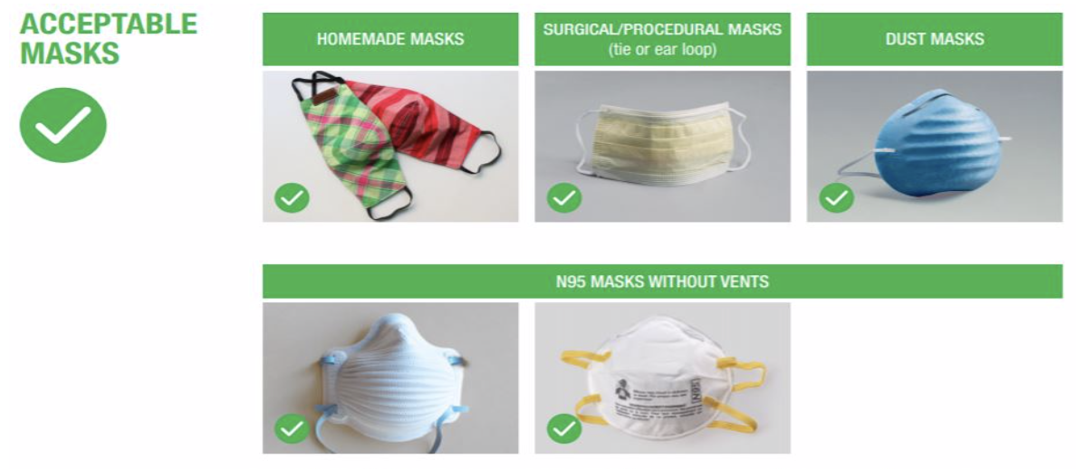

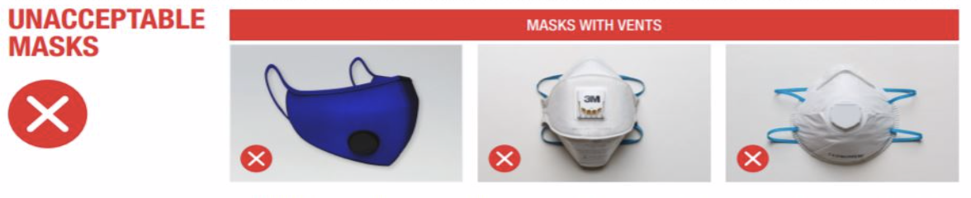
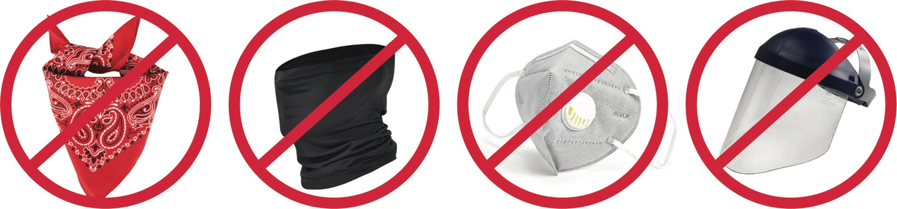
Why? Bandanas, gaiters, face masks with vents/exhalation valves and face shields allow unfiltered exhaled air to escape. This is an unacceptable form of source control as a universal mask while on school property.

